RADIAN - RADar-based Intelligent Activity moNitoring
Matthew Blackwell
Mitch Hoffman
Wyatt Johnson

Execution Timeline

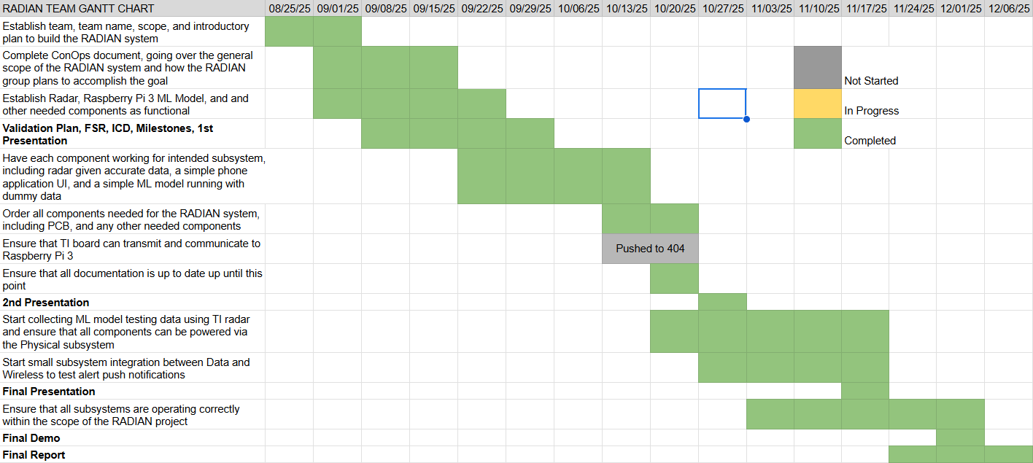
RADIAN - RADar-based Intelligent Activity moNitoring
Matthew Blackwell
Mitch Hoffman
Wyatt Johnson

Validation

Power Subsystem
Test | Description | System | Status
WEBENCH Design Simulation | Steady-state, startup, load-transient, and input-transient simulations validate TPS61022 component choices and operating margins | Boost | Completed
ERC/DRC Sign-off | Run schematic/PCB ERC/DRC and waive labeling issue on charger/boost connection | Power Board | Completed
Footprint/BOM Cross-Check | Verify charger, boost, holders, and connector footprints and pin mappings against datasheets | Power Board | Completed
Power Tree Review | Review voltage and current budgets against loads and IC ratings. | Power Board | Completed
Visual & Dimensional Check | Inspect bare PCB size, hole locations, silkscreen, and solder mask vs. the fab drawing | Power Board | Completed
Solderability Check | Test pad finish quality by tinning a coupon/pad and inspecting wetting | Power Board | Completed
Fit Check: 18650 Holders & Connectors | Verify 18650 holders, barrel jack, and connectors seat flat and align with holes before reflow | Power Board | Completed
Reflow Profile Check | Apply paste and reflow; confirm thermal profile is within datasheet limits for ICs | Assembly | Completed
Microscope Inspection | Inspect IC pins and passives for bridges, voids, tombstones, and poor fillets | Assembly | Completed
Polarity/Orientation | Check diodes, LEDs, electrolytics, and IC pin 1 orientation vs. silkscreen | Assembly | Completed
Resistance-to-GND Check | Measure resistance from +BAT and +5 V rails to GND to catch gross shorts before power-on | Power Board | Completed
Limited Bench Power-On | Power VIN from bench supply with current limit; confirm reasonable idle current and no hot spots | Charger/  Boost | Completed
Key Node DC Sanity | Check VIN, battery node, and 5 V rail voltages with no load | Power Board | Completed
Charger Bench Emulation | Emulate battery with bench supply; verify TP4056 charge behavior and status pins vs. datasheet | Charger | Completed
Single-Cell Charge Profile | Charge 18650 cell; log battery voltage over time to confirm CC/CV behavior and termination | Charger | Completed
Dual-Cell Pack Charge Curve | Charge 2 * 18650 batteries; record battery voltage vs. time | Charger | Completed
Charge + Boost Operation | Run TP4056 charging while the boost converter supplies 5 V rail; check for heating or instability | System | Completed
No-Load Output | Measure 5 V rail at no load; verify approximately 5.0 V regulation | Boost | Completed
Startup Under Load | Verify the boost circuit can start up under load | Boost | Completed
Raspberry Pi Load Test | Power Raspberry Pi 3 from the board; verify successful boot and stable ~4.9–5.0 V rail | RADIAN System | Completed
Audible Alarm | Test the decibel of the audible alarm | RADIAN System | Future work

Radar Subsystem
Test | Description | System | Status
UART Communication Integrity Test | Radar correctly transmits binary TLV packets and Python script decodes them | Radar | Completed
Point Cloud Accuracy Test (static target) | Radar accurately reports x, y, z coordinates of stationary object | Radar | Completed
Point Cloud Accuracy Test (moving target/velocity) | Radar accurately reports Doppler-based velocity estimation | Radar | Completed
Multiple Object Detection Test | Radar can detect more than one target simultaneously | Radar | Completed
Configure File Test (.cfg integration) | Ensure custom configurations change radar behavior | Radar | Completed
Real Time Terminal Display Test | Python file displays live point cloud data without delay or crash | Radar | Completed

App Subsystem
Test | Description | System | Status
App Navigation Test | All tabs function and route correctly | App | Completed
Alert Simulation Test | Fall simulation button triggers critical alert logic | App | Completed
Settings and Server Connection Test | Validate server connection workflow | App | Completed
Gotify Push Notification Test | App receives live notifications from server | App | Completed
Weekly Fall Log Generation Test | Validate automatic weekly log creation | App | Completed
Data Persistence Test | Fall logs persist after app close/restart | App | Completed
UI Responsiveness Test | App layout works on multiple screen sizes | App | Completed

Notification Subsystem
Test | Description | System | Status
Pi-Server Connectivity Test | Verify Raspberry Pi can reach the laptop/host running Gotify via local IP (ping test) | Notification Server | Completed
Gotify Installation Verification | Confirm Gotify server is installed on the Raspberry Pi by inspecting the pip list and verifying the package | Notification Server | Completed
Gotify UI and Token Setup | Test Gotify UI in a web browser via the laptop IP address and create/share the application token for RADIAN | Notification Server | Completed
Basic Message Publishing | Test Python script sending a “Hello World” message via HTTP POST from the Pi to Gotify and verify it appears in the Gotify UI | Notification Server | Completed
Invalid Token Handling | Test server behavior with an incorrect app token and confirm that an error is reported, and the message is not accepted | Notification Server | Completed
Repeated Message Stability | Test repeated message sends in rapid succession from Pi to Gotify and verify no alerts are dropped | Notification Server | Completed
Server Restart Recovery | Restart the Gotify server and confirm it resumes normal operation and can receive new messages | Notification Server | Completed

Artificial Intelligence Subsystem
Test | Description | System | Status
Model Training & Confusion Matrix Check | Verify the random forest classifier correctly separates static vs dynamic motion; inspect accuracy and confusion matrix on synthetic data | Artificial Intelligence | Completed
Synthetic Frame Verification | Run the classifier on known synthetic test frames and verify that predicted labels match the expected labels | Artificial Intelligence | Completed
Edgecase Generation & Inclusion | Generate edge cases (sitting, bending, kneeling, lying down slowly, trip recovery, crawling, pet walking, object drop, hard fall) and include them in training | Artificial Intelligence | Completed
Fall Logic Edgecase Validation | Run the full pipeline (preprocessing, classification, fall detection) on edge cases to verify “No Fall Detected” in non-fall scenarios | Artificial Intelligence | Completed
Normal Fall Scenario Validation | Run the full pipeline on normal fall test cases to verify the system outputs “Fall Detected” when appropriate | Artificial Intelligence | Completed
Demo Accuracy Verification | Confirm that the ML model reaches the current 89% accuracy target during demo conditions, meeting the verification plan | Artificial Intelligence | Completed
Real-Time Performance on Raspberry Pi | Check that point-cloud processing, ML inference, and fall logic run within real-time constraints on the Raspberry Pi without overloading the system | Artificial Intelligence | Completed

